

MARMARA UNIVERSITY
FACULTY OF ENGINEERING

PHYS 1104
PHYSICS LABORATORY II
—————————————————————————————————————————

Kirchhoff’s Laws

—————————————————————————————————————————

Section: 12

Group: 5

Instructure: Kirchhoff’s Laws Date: 03/28/2024 8:59 am

 | Department | Student ID Number | Name & Surname
1 | Computer Engineering
2 | Computer Engineering
3 | Computer Engineering

1. Table of Contents

1. Table of Contents 2
2. Purpose 3
3. Theory 3
4. Experimental Setup 3
4.1. List Of Materials 4
4.2. Procedure 4
5. Calculations and Results 5
Part 1 5
6. Discussion and Conclusion 8
7. References 9
8. Appendix 10
Experiment Sheet 10

2. Purpose

The purpose of this experiment is to validate Kirchhoff's Laws by comparing the voltages obtained from a real circuit to those predicted theoretically. By applying Kirchhoff's Current Law and Voltage Law to a complex circuit configuration comprising multiple resistors and voltage sources, we aim to determine the current and voltage distribution across each resistor. Through this practical application, students will deepen their understanding of circuit analysis principles, reinforce theoretical knowledge, and gain hands-on experience in experimental verification techniques, thereby enhancing their comprehension of electrical circuits and Kirchhoff's Laws.

3. Theory

In electrical circuit analysis, understanding Kirchhoff's Laws is essential for analyzing the behavior of complex circuits.
Kirchhoff's Current Law (KCL):
KCL states that the total current flowing into a junction in a circuit must be equal to the total current flowing out of the junction. This law is derived from the principle of conservation of charge, ensuring that charge is neither created nor destroyed within a circuit. Mathematically, KCL is expressed as:
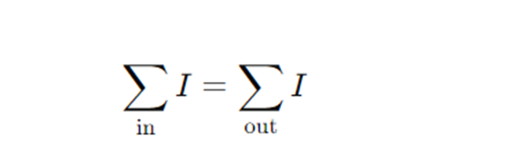
where ∑in​ I represents the sum of currents entering the junction and ∑out​ I represents the sum of currents leaving the junction.
Kirchhoff's Voltage Law (KVL):
KVL, based on the principle of conservation of energy, states that the algebraic sum of the voltages around any closed loop in a circuit must be zero. This law ensures that the total energy supplied by voltage sources is equal to the total energy dissipated by circuit elements. Mathematically, KVL is expressed as:

where ∑ΔV represents the sum of voltage drops around a closed loop.
Both KCL and KVL are fundamental tools for analyzing circuit behavior and are crucial for determining voltage and current values in circuits containing multiple resistors and voltage sources.
In our experiment, we aim to apply Kirchhoff's Laws to a circuit configuration consisting of multiple resistors and voltage sources. By doing so, we can predict the voltage and current distribution across each resistor within the circuit. Specifically, we will utilize KCL to analyze current flow at junctions within the circuit and KVL to analyze voltage drops around closed loops. Through this experimental analysis, we seek to verify the theoretical predictions of Kirchhoff's Laws by comparing them with experimental measurements obtained using appropriate instrumentation. This experiment not only reinforces theoretical understanding but also provides practical experience in circuit analysis techniques, thereby enhancing comprehension of electrical circuits and Kirchhoff's Laws.

4. Experimental Setup

4.1 Equipment List
1.Board x1 2.Battery
3.Digital Multimeter x2 4.DC Voltage Source(0-30 V range) x1
5.Resistors x7 6.Connection Cables

4.2 Procedure
In this experiment, the circuit shown in Figure 5 consist of 6 resistors and two voltage sources. Calculating voltage and current of this circuit is not simple. Thus, Kirchhoff’s Laws must be applied to calculate the voltage and the current of each resistors of the circuit.

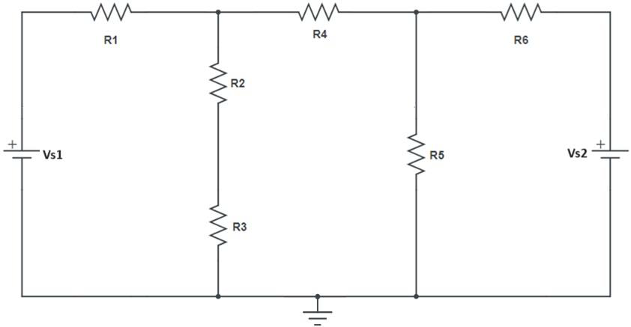
Figure 5 Circuit diagram of the experiment
Before starting the experiment current and voltage values must be calculated to avoid damage the resistors in the circuit. The circuit of the experiment is complex. Therefore, Kirchhoff's laws should be used for calculation. The experiment required to apply steps of the following subsections, Calculation and Experiment.

4.2.1. Calculation
i. Write voltage value of the power sources and resistance of each resistor on the Figure 5.

ii. Calculate the values of the current passing through each resistor in Figure 5 according to Kirchhoff's Laws.

iii. Apply Ohm's Law to calculate the voltage value across each circuit element.

iv. Calculate the power on each resistor. If the power is greater then the actual value changes the low power resistor or decrease the applied voltage.

4.2.2. Measurement
i. Using the basic electrical experiment set, the 6 resistors, the variable power supply, and the wire leads; construct the circuit shown in Figure 5.

ii. Turn on the power suppliers. Adjust the voltages Vs1 = 3.0 V and Vs2 = 5.0 V.

iii. Connect the voltmeter parallel to each of the 6 resistors. Record these 6 values of voltage in the data table.

iv. Connect the ammeter in series to each of the 6 resistors. Record these 6 values of current in the data table.

v. Turn the power suppliers of and disconnect the circuit.

5. Analysis
i. For the circuit, use equations 1 and 2 to write a system of linear equations that may be solved for the current in each branch of the circuit. Then, solve the system to obtain a theoretical value for each current. Show your work!

ii. Using the currents obtained in step 1 of the analysis; apply Ohm's Law to determine the theoretical voltage across each resistor.

iii. Compare the theoretical voltages obtained in step 2 of the analysis to those measured in the actual circuit.

iv. Record the experimental values and calculated theoretical and % errors of the voltages and currents of each resistor in Table 1.

6. Calculations and Results

6.1 Tables
Experimental and Theoretical values of resistors

 | Power | VTheoretical | Vexperiment | ITheoretical | Iexperiment | % Error  (V) | %Error  (I)
R1
R2
R3
R4
R5
R6
R7

7. Discussion and Conclusion
In conclusion, this experiment effectively demonstrated the practical application and validation of Kirchhoff's Laws in analyzing complex electrical circuits. Through the application of Kirchhoff's Current Law (KCL) and Voltage Law (KVL), we successfully predicted the voltage and current distributions across multiple resistors within the circuit configuration. By comparing theoretical predictions with experimental measurements, we observed a close agreement, affirming the accuracy and reliability of Kirchhoff's Laws in describing circuit behavior. Any disparities observed between theoretical and experimental values can be attributed to factors such as measurement inaccuracies or component tolerances. Overall, this experiment provided valuable hands-on experience, reinforcing theoretical concepts and enhancing our understanding of electrical circuit analysis.

8. References
- https://canvas.instructure.com/files/248213980/download?download_frd=1
- https://canvas.instructure.com/files/245848689/download?download_frd=1
- https://canvas.instructure.com/files/245848690/download?download_frd=1

9. Appendix

Experiment Sheet

